**DYNAMIC WEB PROGRAMMING**

**PRACTICUM 4**



**By:**

**GANNO TRIBUANA KURNIAJI**

**NIM: L200184092**

**INFORMATION TECHNOLOGY**

**FACULTY OF COMMUNICATION AND INFORMATICS**

**UNIVERSITY OF MUHAMMADIYAH SURAKARTA**

**2020**

1. **Experiment 1**

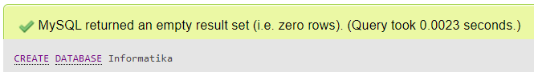

1. **Experiment 2**



1. **Experiment 3**

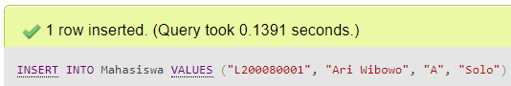

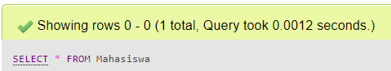

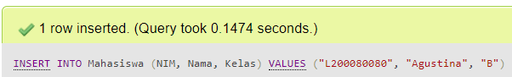



1. **Experiment 4**

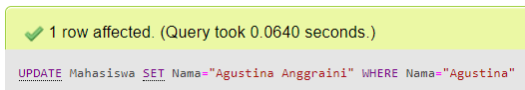





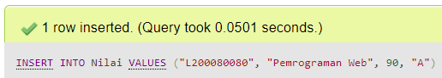

1. **Experiment 5**



1. **Experiment 6**



1. **Experiment 7**



1. **Experiment 8**

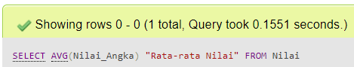

1. **Experiment 9**

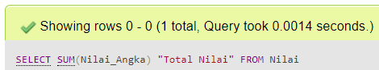

1. **Experiment 10**



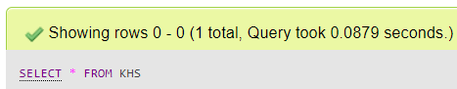

1. **Assignment 1**
2. **SELECT**

The SELECT statement is used to select data from a database.

1. **JOIN**

A JOIN clause is used to combine rows from two or more tables, based on a related column between them.

1. **LEFT JOIN**

The LEFT JOIN keyword returns all records from the left table (table1), and the matched records from the right table (table2).

1. **RIGHT JOIN**

The RIGHT JOIN keyword returns all records from the right table (table2), and the matched records from the left table (table1).

1. **AVG**

The AVG statement finds the average price of all products.

1. **SUM**

The SUM statement finds the sum of the "Quantity" fields in the "OrderDetails" table.

1. **Assignment 2**

